Assignment 1

1. Install Jupyter notebook and run the first program and share the screenshot of the output.  
**CODE:**

# Factorial of a Number

print('Please enter the number:')

n = input()

def fact_num(n):

if n < 0:

return -1

else:

fact = 1

for i in range(1, n+1):

fact *= i

return fact

print('The factorial of the number',n,'is',fact_num(6))

**Output**

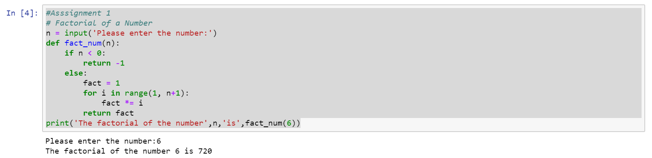

2. Write a program which will find all such numbers which are divisible by 7 but are not a

multiple of 5, between 2000 and 3200 (both included). The numbers obtained should be printed

in a comma-separated sequence on a single line.

**CODE:**

# Assignment 1

nl=[]

for x in range(2000, 3201):

if (x%7==0) and (x%5!=0):

nl.append(str(x))

print('The numbers divisible by 7 but are not a multiple of 5:')

print (','.join(nl))

**OUTPUT**

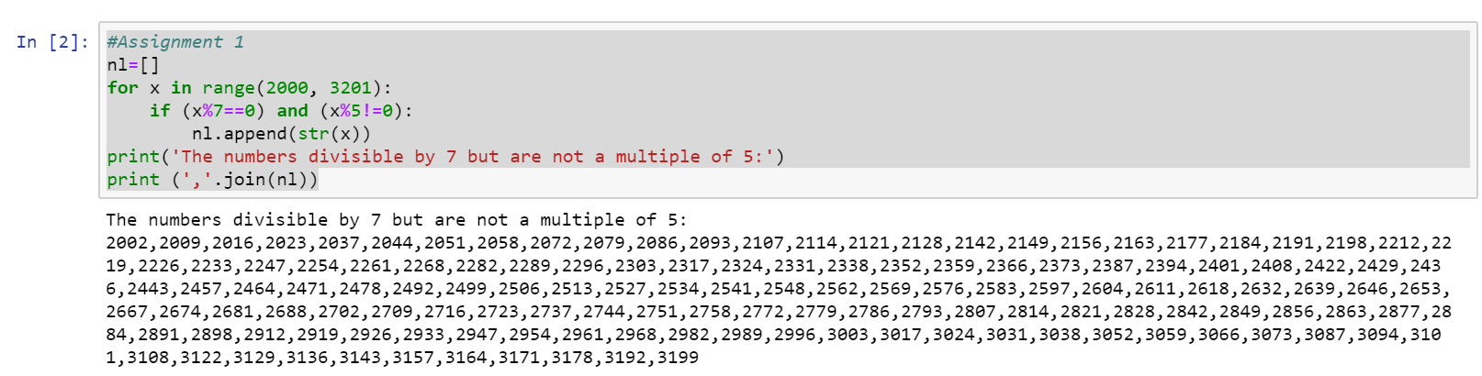

3. Write a Python program to accept the user's first and last name and then getting them printed

in the reverse order with a space between first name and last name.

**CODE:**

#Assignment 1

fname = input("Input your First Name : ")

lname = input("Input your Last Name : ")

print ("Hello " + lname + " " + fname)

**OUTPUT**

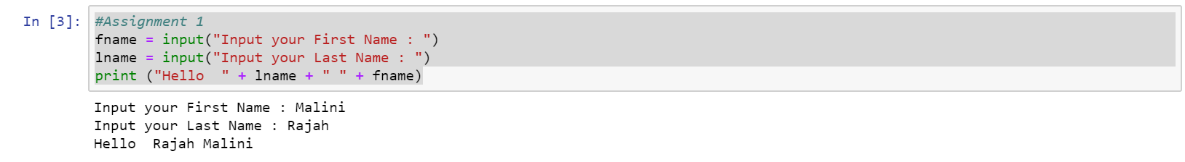

4. Write a Python program to find the volume of a sphere with diameter 12 cm.

Formula: V=4/3 * π * r3

**CODE:**

#Assignment 1

PI = 3.14

diameter = 12

radius = diameter / 2

volume = (4/3)*PI*radius*radius*radius

print ("Volume of the sphere = ",volume)

**OUTPUT**

